WELLNESS HUB
Explore mental health insights, lived experiences, and awareness resources.
(BLOG THEME 1) Autism Spectrum & Neurodiversity
( BLOG 1 )AUTISM SPECTRUM DISORDER 2022-11-11
Understanding ASD, its characteristics, and early signs.
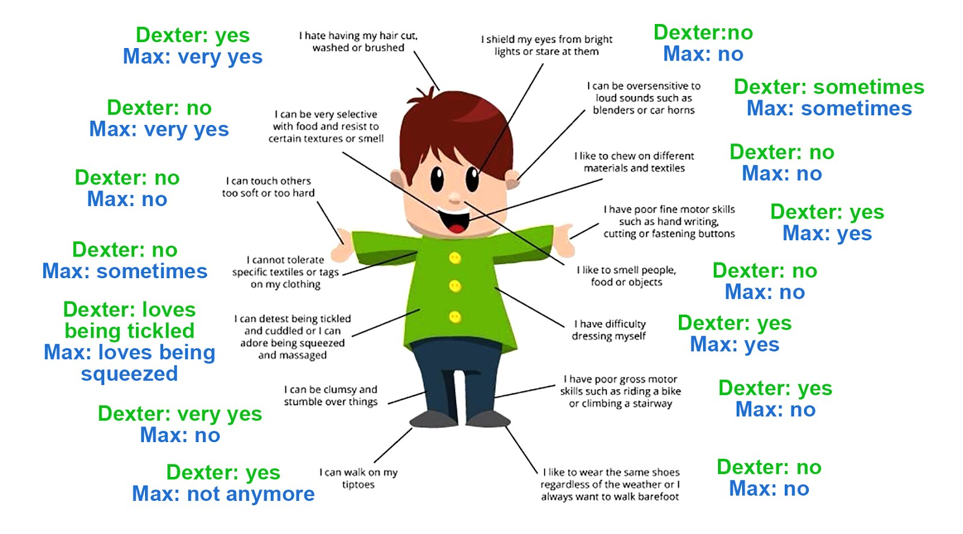

Symptoms
? I cannot initiate communication
? I fail to respond actively
? I don�t use language properly
? I cannot share my interests
? I cannot properly engage in social games
? I fail to share emotions with others such as a smile/praise
? I fail to use eye contacts
? My body postures are unusual
? My speech has unusual volume, tone and pitch
? I fail to use proper facial expressions
? I cannot coordinate my verbal and non-verbal behaviors
? I fail to notice others emotions such as distress/disinterest
? I fail to cooperate with others
? I am not aware of the social environment
? I am usually withdrawn
? I repeat whatever other speak
? I repeat movements such as clapping and teeth grinding
? I have unusual routines
? I don�t understand humor
? I can tolerate any amount of pain
? I may poke my own eyes or lick objects

( BLOG 2) Interventions for Autism Spectrum Disorder (2022-11-11)
Evidence-based therapies and support approaches for individuals with ASD

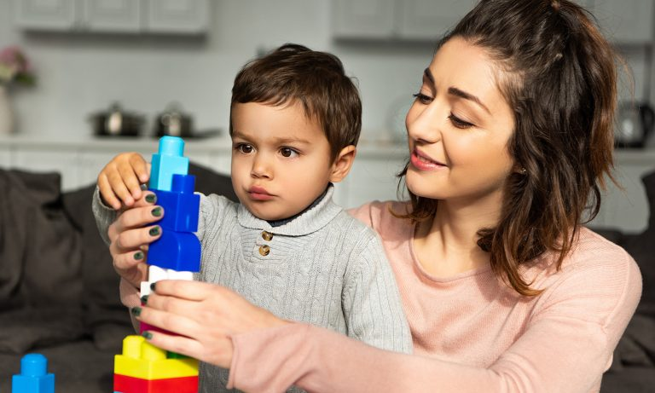
There are various interventions that have helped improve the quality of life for many individuals with an autism spectrum diagnosis. Some of them have been described below:
Applied behavior analysis (ABA)
ABA is used for describing programs that adhere to certain principles and not to any specific program or procedure. One of the key principles is the analysis and measurement of relations between environment and behavior. ABA programs aim to teach new skills and generalize them across different settings. The focus is on reinforcing desirable behaviors and decreasing behaviors of concern. They are used to teach academic and vocational skills, increase speech, social skills, play skills, and also decrease problem behaviors. Also, in recent times, there has been an emphasis on implementing the program in the child�s naturalistic settings. For behaviors that are challenging, the most common approach is to conduct an assessment of the environmental events which elicit and maintain problem behaviors, called functional analysis. Following this an attempt is made to replace problem behavior with a more acceptable behavior like requesting for a toy.
Social skills training
ASD involves difficulties in social interaction. Social skills training teaches children the skills they need to interact with others, including conversation and problem-solving skills. Use of ABA methods, social narratives/stories, peer-mediated interventions or social skills groups are some ways for teaching social skills.
Cognitive behavior therapy
The use of CBT with individuals with ASD is growing. The focus of CBT is on replacing negative or ineffective patterns of thought and behavior with strategies that are effective in enhancing mood and adaptive functioning. Support for �self-management�, a type of CBT, designed for higher functioning children/adolescents or adults with ASD is growing. This has been found to support the management of anxiety, depression, anger control, and social skills. It has helped people with ASD, to learn to independently regulate their own behaviors and act more appropriately in a variety of settings.
Medication
Many psychiatric disorders in children are managed by medications, some of which have symptoms overlapping with those seen in children with ASD. These include hyperactivity, inattention, obsessive-compulsive behaviors, anxiety, etc. But there are no medications that treat the social and language impairments of ASD. The medications used most frequently for children and adults include those for managing the above-mentioned symptoms though their use is challenging and not without risks.
Augmentative and Alternative Communication (AAC)
AAC is helpful to make up for the deficits in expressive communication with interventions ranging from the use of sign language to picture systems and more complex electronic communication devices. This intervention can be used at any age. One popular strategy is the �Picture Exchange Communication System� (PECS) wherein individuals are trained to exchange picture cards for desired items. The therapist uses a label for each item. It also reinforces attempts to initiate social contact.
Visual Supports
For many children with ASD, the use of visual supports has been linked to a positive effect on their learning, behavior, and social skills. Some examples include the use of schedules, picture exchange systems, and structured teaching. More often than not they are used in conjunction with other interventions.
Other therapies include occupational therapy, sensory integration, and parent-implemented interventions. Sensory Integration (SI), is popular though not much evidence base has been found. Many children with ASD are thought to have a form of sensory integration dysfunction, which may lead to hypersensitivity or hyposensitivity to sensory input, activity levels that are unusually high or low, problems with coordination etc. It involves evaluating a child�s sensory needs to decide on activities to support those needs which may include swinging, jumping and more. It is usually implemented by occupational therapists. Occupational therapy on the other hand teaches skills that help an individual live as independently as possible. Skills may include dressing, eating, bathing, and relating to people.
Complementary and alternative medicine (CAM) treatments
These include the use of melatonin. Research has found that melatonin can help children with ASD to fall asleep. A gluten-free, casein-free (GFCF) diet and nutritional supplements like B6, Magnesium, B12 are other treatments. Talking about the GFCF diet, an inability to effectively metabolize gluten and casein (proteins), in some severe cases, had been linked to gastrointestinal or neurological problems. It has been proposed that ASD symptomology may be associated with this process. Though there is limited research for the efficacy of these treatments.
References
Kopelman, T. (n.d.). Interventions for autism spectrum disorders (ASD). Retrieved from
https://uichildrens.org/health-library/interventions-autism-spectrum-disorders-asd
Lindgren, S., & Doobay, A. (2011). Evidence-based interventions for autism spectrum disorders.
Retrieved from
https://www.interventionsunlimited.com/editoruploads/files/Iowa%20DHS%20Autism%20Interventions%206-10-11.pdf
(BLOG 3) Do Vaccines Cause Autism? Breaking A Few Myths About ASD (2022-11-11)
Addressing misinformation and clarifying scientific facts around autism

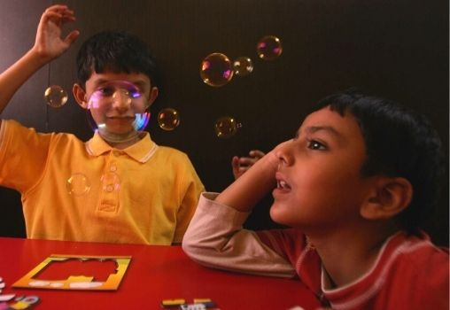

Autism Spectrum Disorder or ASD is a neurodevelopmental disorder that manifests in the form of difficulties in social interaction and communication as well as restricted and repetitive patterns of behavior. ASD is considered a �spectrum� disorder because individuals on the spectrum vary greatly with regard to the range of symptoms and severity of the disorder.
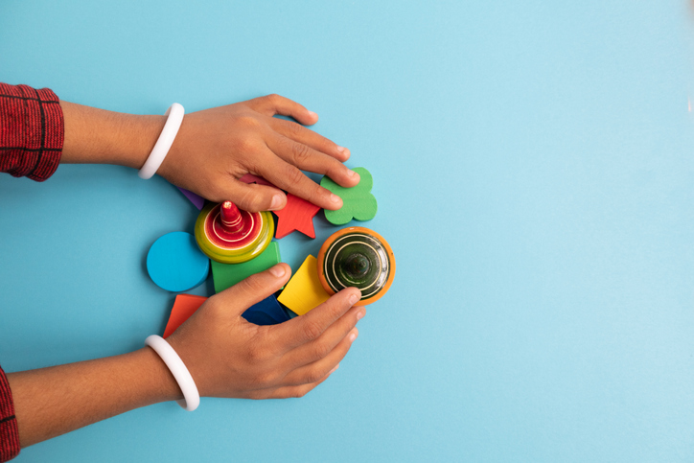
Most individuals with autism have IQs that fall in the typical or above-average range.

ASD usually manifests in the early years of life and is usually apparent by age 5. The WHO estimates that one in 160 children falls on the autism spectrum. Because the profile of diagnosed individuals varies so greatly, as well as lack of awareness, there are many myths about autism. Some of these prevalent myths will now be deconstructed.

Myth 1: Vaccines cause Autism
The growing anti-vaxxer movement has contributed to this myth, with allegations that the measles-mumps-rubella vaccine causes autism. However, no rigorous large-scale study has given credence to this myth.

Myth 2: People with autism also have an intellectual Disability
This myth is not entirely untrue. While some individuals with autism have an intellectual disability, others have IQs that fall in the typical or above-average range. What is true is that for many children with autism, typical procedures for measuring IQ are not applicable, which may cause difficulties in IQ testing or misreport of scores.

Myth 3: Autism is a condition that can be outgrown or Cured
There is presently no cure for autism spectrum disorder, and once diagnosed, people will remain on the spectrum throughout their lives. However, with early intervention, most individuals with autism can lead a full and successful life.

Myth 4: All people with autism have the same skills and Difficulties
As mentioned previously, autism is a spectrum disorder, which means that those diagnosed with autism show a wide range of symptoms at varying levels of severity. Every individual with autism is unique and may have their special topic of interest.

Myth 5: People with autism do not experience the full range of emotions and cannot build strong Relationships
While people with autism may experience difficulties expressing emotions, it does not mean that they don�t experience the full range of emotions. Individuals with autism show affection and emotions differently, and often have strong bonds with people who are important to them.
Moreover, it is important to remember that rather than focusing on the so-called limitations of ASD, autism also brings certain positives. People with autism often show enhanced attention to detail, observational skills, creativity and recall than the general population.
Additionally, individuals on the spectrum may often take novel approaches to address problems and may also be more accepting of differences (Bennie, 2019).
To conclude, ASD is a complex and nuanced disorder and no two people with ASD are alike. With the help of love, support and timely intervention, individuals with ASD can develop the social and behavioral skills to live fulfilling lives.
(BLOG 4) I Am An Adult With A Late Diagnosis Of Asperger’s Syndrome And This Is My Story (2022-11-11)
A personal narrative exploring late diagnosis, identity, and self-acceptance.

People in India are still not comfortable with the fact that someone can be suffering from a mental health or neurological health issue. For many of them, it�s a hush-hush topic and something that shouldn�t be discussed out loud. I am an adult with a late diagnosis of Asperger�s Syndrome. It means I am a high-functioning autistic.
My brain is wired differently than most of the population and this is the reason why I act and react to various things in a different manner. For example, I am highly empathetic and most of the time I can feel the feelings of other people as well. No two autistic people are the same and that�s why it is called a spectrum disorder. People on the spectrum show various kinds of traits and hence, may seem to be someone who is living in their own world.
Autism is still not well-understood by the masses in our country and that is why many people are left undiagnosed throughout their life. One major reason for this is the awkwardness and fear of talking to a psychotherapist or psychiatrist. A general term that is used for these doctors or therapists is �pagal� or �pagalo ka doctor�, which means that the person who goes to these people is �mental� or �a nutcase�.
Autism is still not well-understood by the masses in our country and that is why many people are left undiagnosed throughout their life. Representative image.
One needs to understand that our brain reacts to issues such as depression, anxiety, panic etc. in the same manner as our physical body reacts to injuries and pain. We as humans have always feared things that are unknown or cannot be seen and hence, we have never been able to talk about mental health. Just like we go to a doctor without hesitation in case of a physical injury, it shouldn�t be difficult for us to go to a psychotherapist or psychiatrist in case of a mental health condition.
Autism is a vast subject and very little research has been conducted on it in our country and in our cultural context. If people are more acceptable or open to acceptance, things could be made easy for people like me who still haven�t been diagnosed, are living in fear, and have been branded as �weird� or �pagal� by their peers.
Note: The article was originally published here.

(BLOG THEME 2) 2. Abuse, Trauma & Domestic Violence
( BLOG 1) Gaslighting: When It’s Not All In Your Head
Recognizing emotional manipulation and psychological abuse.
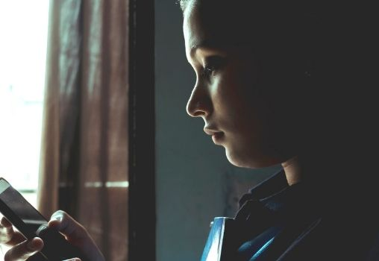
Gaslighting is a form of emotional abuse, in which the abusive partner leads the victim to question their feelings, instincts, and sanity. Through this process, the abusive partner breaks down the victim�s ability to trust their own perceptions. Consequently, the victim�s probability of staying in an abusive relationship increases.
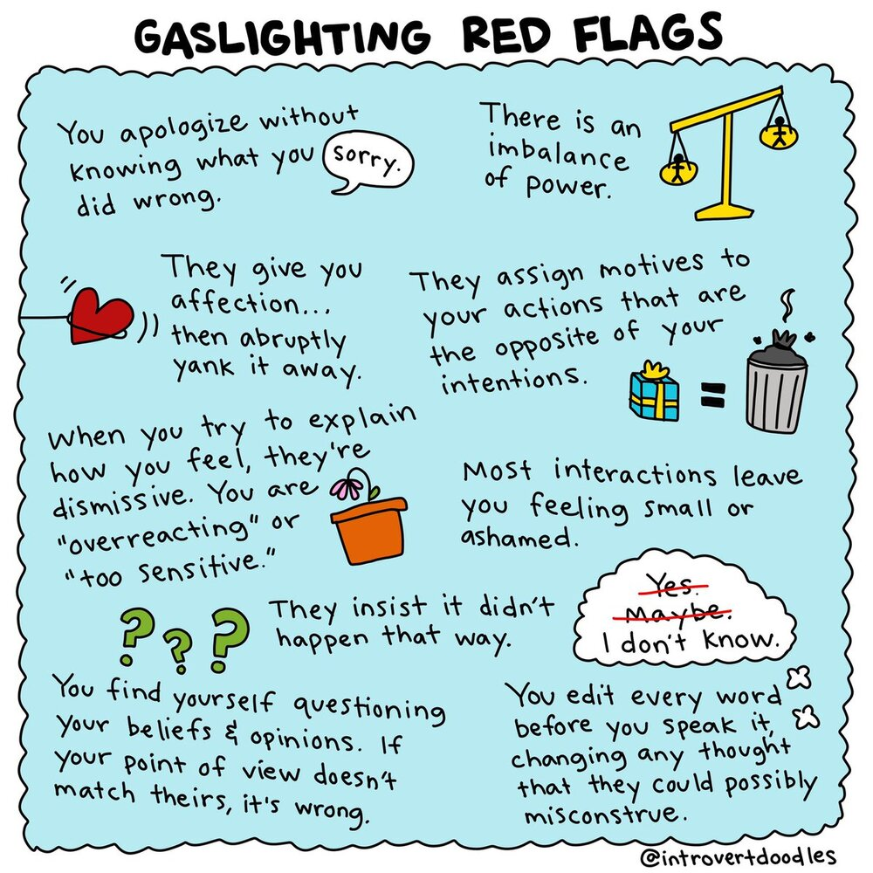
The term �gaslighting� comes from a 1938 play, Gaslight, in which the lead character tries to drive his wife crazy by making her question her sanity- this is accomplished by the husband dimming the (gas) lights at home, but denying that they have dimmed to his wife. The distinguishing feature of gaslighting is that the abuser not only controls the victim but also has
they agree with the abuser�s point of view (Abramson, 2014).
Gaslighting is typically persistent and long-term, and the abusers characteristically have trouble identifying and expressing emotions and tend to have low self-worth. It is a gradual process, and may initially seem like a misunderstanding of the perpetrator�s actions. However, these behaviors usually escalate over time, and the abusive behaviors cause the victim to feel anxious, depressed, and isolated.
Most alarmingly, over time as the victim becomes more distrustful of their perceptions, they start relying on the abusive partner to help define reality, making an escape from the relationship more complicated. Gaslighting is especially common among victims of domestic abuse.
Also read: Quick Byte: Heard About �Gaslighting�? Here�s What It Is
Gaslighters use a variety of techniques. These include:
- Withholding: In this technique, the abuser pretends not to understand or refuses to listen to the victim, e.g. �You�re trying to confuse me.�
- Countering: By employing this technique, the abuser tries to make the victim question their memory of events, e.g. �You never remember things correctly.�
- Trivializing: This strategy aims to undermine the victim�s needs or feelings, e.g. �You�re too sensitive.�
- Blocking/Diverting: The abuser changes the topic or questions the victim�s thoughts in this strategy, e.g. �You�re imagining things.�
- Forgetting/Denial: Through this technique, the abuser claims to forget or denies events or promises made to the victim, e.g. �You�re making stuff up.�
Some of the signs of gaslighting are:
- Constantly second-guessing yourself.
- Constantly apologizing to your partner.
- Feeling confused or crazy.
- Asking yourself repeatedly if you�re �too sensitive�.
- Difficulty in making simple decisions.
- Feeling as if you cannot do anything right.
- Wondering if you are a good enough partner.
It is extremely important for victims of gaslighting to learn about these signs to reach out and seek help and relearn how to trust themselves.

References:
- Abramson K (2014) Turning up the lights on gaslighting. Philos Perspect 28(1):1�30 Spear, A. (2018).
- Gaslighting, Confabulation, and Epistemic Innocence. Retrieved from https://link.springer.com/content/pdf/10.1007/s11245-018-9611-z.pdf.
- What is Gaslighting? � National Domestic Violence Hotline. (n.d.). Retrieved from https://www.thehotline.org/what-is-gaslighting/.
(BLOG 2) Domestic Violence: The Indian Picture
An overview of domestic violence in India, its psychological impact, and the need for awareness

n India, domestic violence is legally defined as �actual or threats of physical, mental, emotional, sexual or verbal abuse, as well as harassment regarding dowry or property.� It is prevalent across all sections of society in the country. The signs of domestic violence may not always be obvious and a large percentage of domestic violence cases never see the light. According to the National Family Health Survey, 27% of women above the age of 15 have experienced physical violence at home, with the numbers being slightly higher for rural families (Saaliq, 2018). Moreover, 31% of married women in India face physical, sexual or emotional violence at the hands of their husbands. Notably, economic violence, in the form of withholding money or economic resources is not taken into account in statistics. Oftentimes, domestic violence cases don�t make it to the court as the woman�s family may face shame and guilt and also because the burden of proof is placed on women.
Domestic violence has several mental health implications. This includes an increased occurrence of depression and anxiety among victims of domestic violence. Additionally, victims may also develop post-traumatic stress disorder or PTSD, which may result in associated flashbacks, nightmares, hyper-vigilance etc. In severe cases, victims of domestic violence may be
driven to self-harm or even suicide. Additionally, many perpetrators of domestic violence may engage in gas-lighting, which is �a technique of psychological manipulation that makes the victim doubt their sanity�.
Finally, victims of domestic violence may also fall into a cycle of learnt helplessness, wherein they feel that there is no chance of escape from the abusive situation as previous attempts have not been successful. Therefore they give in and accept their circumstances, and may refuse help when provided (Shah, 2019). In India, the main legal protections against domestic violence come from three laws:
1. The Protection of Women from Domestic Violence Act, 2005.
2. The Dowry Prohibition Act, 1961.
3. Section 498A of the Indian Penal Code.
The first of these, the protection of Women from Domestic Violence Act (2005) is a civil law that protects women in a household from men in a household. This law extends to women who are in live-in relationships. This law also affirms women's rights to seek protection against domestic violence, live in a shared household and get maintenance from the abuser where they are no longer cohabiting.
The Dowry Prohibition act is a criminal law that punishes people asking or demanding Dowry via imprisonment. Section 498A of the IPC is a criminal legislation that applies to husbands or relatives who are cruel to women. Cruelty is defined as any act or conduct that drives women to suicide or harms their physical or mental health grievously (Dharmadhikari, 2019).
All women can contact the National Commission for Women Helpline in case they face domestic abuse at 109/ 1921.
Some additional helplines for women are enlisted below. We hope to raise awareness to support victims of domestic violence.
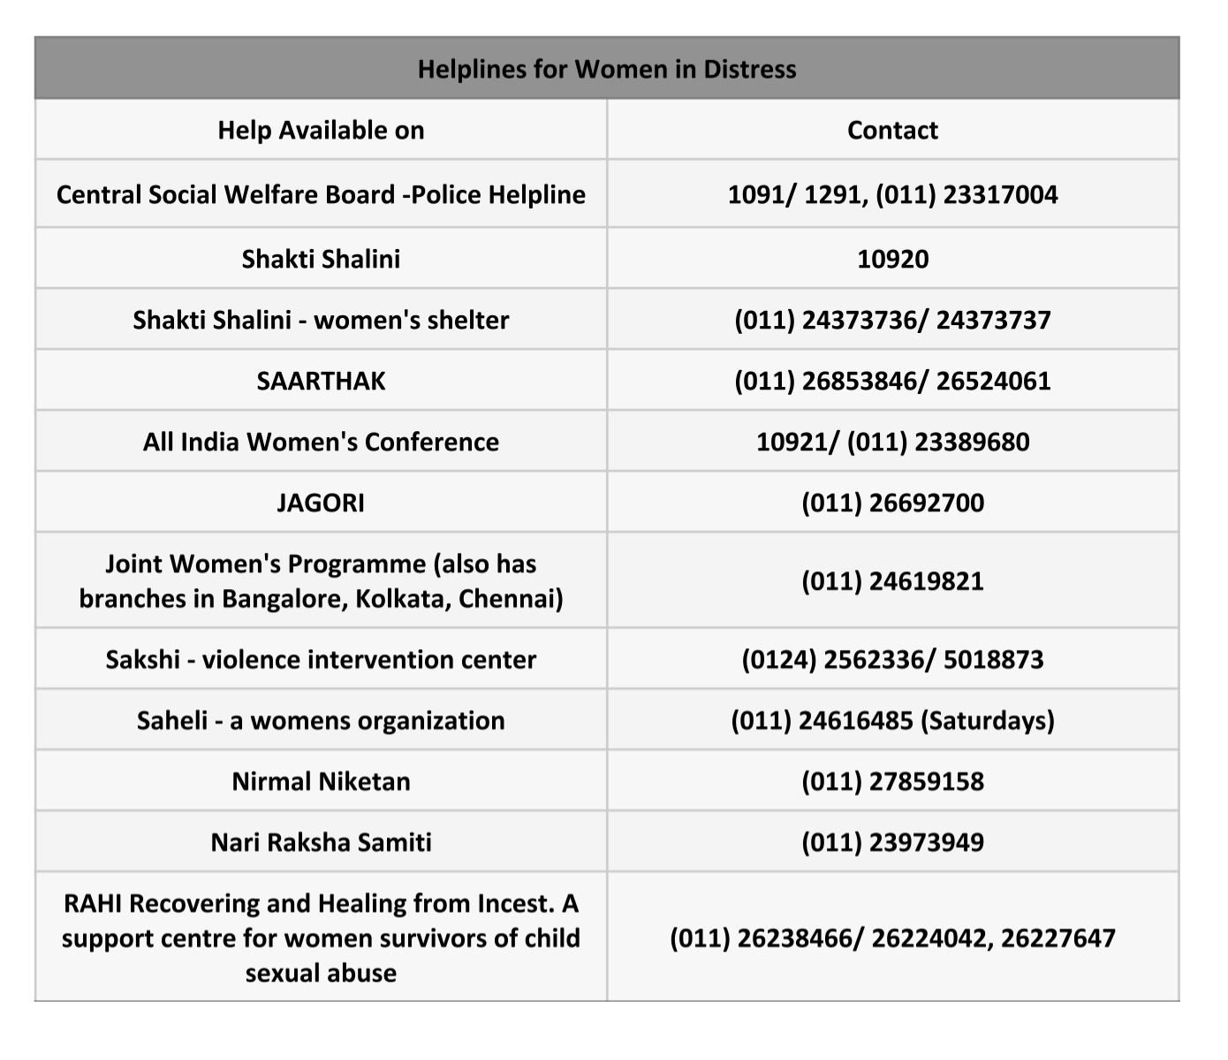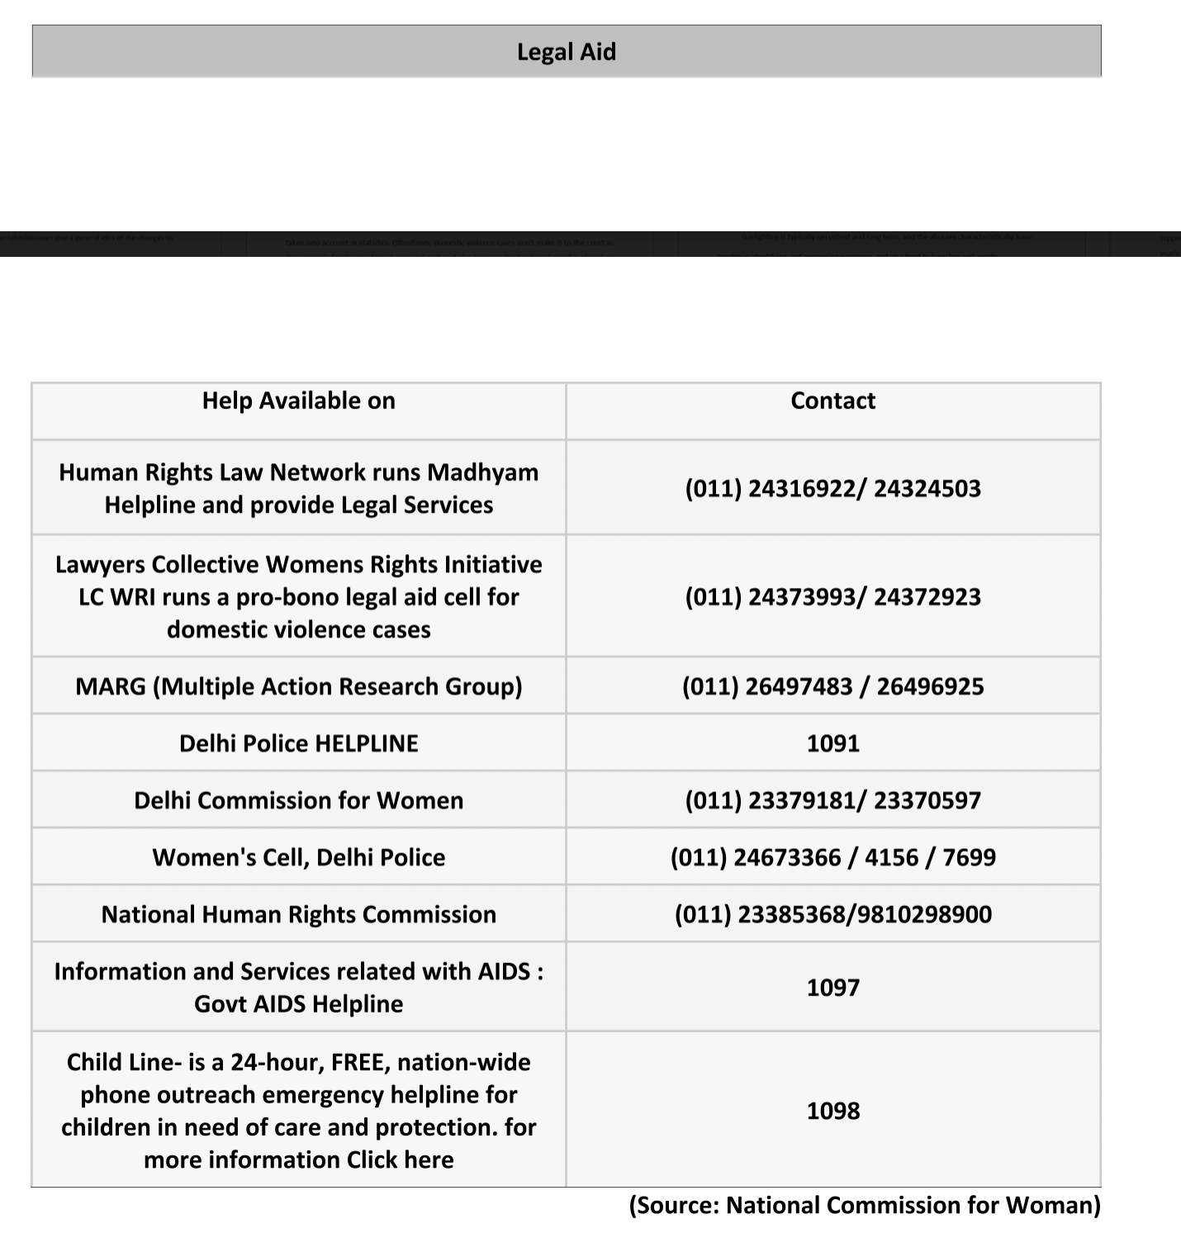

References:
Dharmadhikari, S. (2019). Watch: These are the laws in India against domestic violence. Retrieved from-https://www.thenewsminute.com/article/watch-these-are-laws-india-against-domestic-
violence-97543.
National Commission For Women. (n.d.). Helplines. Retrieved from http://ncw.nic.in/helplines.
Saaliq, S. (2018). Every Third Woman In India Suffers Sexual, Physical Violence at Home. Retrieved from-https://www.news18.com/news/india/the-elephant-in-the-room-every-third-woman-in-india-faces-domestic-violence-1654193.html.
Shah, P. F. (2019). How To Find Domestic Violence Counselling, Helplines And Support In
India. Retrieved from https://www.naaree.com/domestic-violence-helplines-india/.
Women�s experiences of Domestic Violence and Abuse. (n.d.). Retrieved from http://
www.healthtalk.org/peoples-experiences/domestic-violence-abuse/
womens-experiences-domestic-violence-and-abuse/impact-domestic-violence-
And-abuse-womens-mental-health.
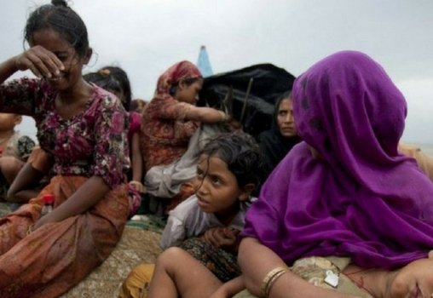

( BLOG 3) Why Do Refugees Show Higher Percentage Of PTSD? (EDITORS CHOICE)
Refugees demonstrate high rates of PTSD and other psychological disorders. The recent increase in forcible displacement internationally necessitates the understanding of factors associated with refugee mental health

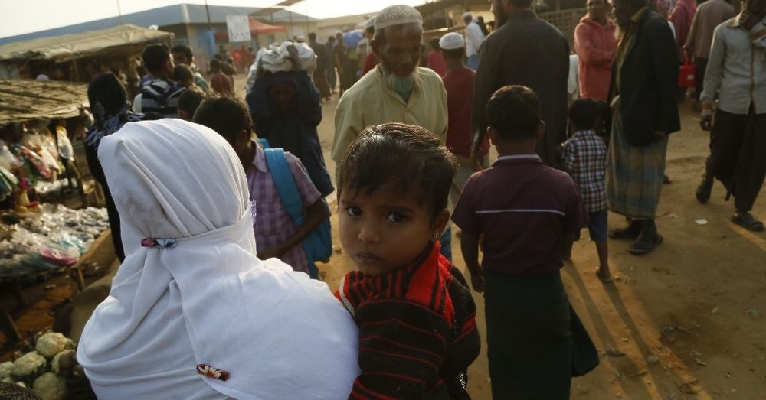
While pre-migration trauma is recognized as a key predictor of mental health outcomes of refugees and asylum seekers, but psychological effects of post-migration stressors in the settlement environment is also a significant factor. A meta-analysis of 181 studies of conflict-affected populations, including refugees and displaced persons, estimated that PTSD is prevalent at 30.6%. (Liddell and Nickerson, 2016)
Migrants are often subjected to specific risk factors for mental health problems, mainly related to exposure to stressful and traumatizing experiences, including racial discrimination, urban violence, abuse by law enforcement officers, forced removal or separation from their families, detention, etc. reclusion, and/or deportation. Stress and trauma have been robustly associated with risks for mental disorder, including but not limited to Post Traumatic Stress Disorder (PTSD), major depressive disorder, psychosis and suicide.
Stress is currently conceptually understood as a complex, multidimensional process by which some environmental factor (the stressor) triggers a physical and psychological response to which the individual must adapt.
Adaptation is understood as a dynamic process by which the individual�s thoughts, feelings, behaviour and bio-physiological mechanisms continually change to fit a changing environment. When the adaptation resources of the organism are overwhelmed, a mental disorder can prevail, with symptoms and associated behaviour, potentially PTSD. As it requires constant adaptation to a new environment, the migration process is generally assumed to be a major chronic environmental stressor. (Bustamante, Cerqueira and Leclerc, 2017)
Survivors of political violence, which includes individuals forced to ?ee their country due to political persecution as well as those who have been subject to physical or psychological torture at the hands of government actors, evidence high rates of anxiety disorders such as posttraumatic stress disorder (PTSD), whether they are resettled in the developing or in Western countries.
Research with this population often focuses on pre-migration traumatic events with little regard to post-migration deprivation and structural needs in countries of resettlement. However, studies that account for post-migration factors indicate that they are important in moderating pre-migration traumatic experiences.
In a meta-analysis of 56 studies of refugees, asylum-seekers, and other displaced persons, Porter and Hassam found that numerous structural post-migration conditions, such as housing accommodation and restricted economic opportunities, moderated mental health outcomes, regardless of resettlement location affect the mental health of the migrants. (Chu and Keller, 2013)
The challenge in offering access to appropriate mental health services to migrants arises from cultural and linguistic barriers and the impact of their exposure to traumatic events and stressors. Traumatic factors are usually associated with the experience of migration, but they could also occur in pre-migratory stages, during the migratory process, or even in the post migratory period. (Bustamante, Cerqueira and Leclerc, 2017)
The impact of resettlement stressors over and above that of pre-migration trauma has substantial implication for practice and service delivery. In particular, the potentially deleterious impact of post-migration difficulties highlights the need for interventions to consider psychological distress in refugees from a psychological perspective rather than simply from a trauma-focused perspective.
Closer examination of the underlying mechanisms that influence the relationship between post-migration stressors and migrant/refugee mental health and longitudinal research to discern causality would be useful to inform policy and interventions that promote better psychological functioning among the migrants.

References:

1. Liddell, B., Nickerson, A. (2016) The Relationship between Post-migration stress and Psychological disorders in Refugees and Asylum Seekers.

2. Bustamante, L., Cerqueira, R., &amp; Leclerc, E. (2017). Stress, trauma and PTSD in migrants: A comprehensive view.

3. Chu, T., Keller, A. (2013). Effects of post-migration factors on PTSD outcomes among immigrant survivors of political violence. Journal of immigrant and minority health, 15(5), pp 890-897.

THEME 3 Child & Adolescent Mental Health
(BLOG 1) What Is The Effect Of Bullying On A Child?
The emotional, behavioral, and long-term mental health consequences of bullying


How Does Bullying Manifest In Schools?

However, there are different ways this flourishing experience can be compromised and in turn, can have serious negative implications. One of the ways is the dreaded term: bullying. Bullying is a dreaded scenario because it is sad to think about what makes children indulge in such acts and what kind of psyche makes them inflict such harm on others.
On the one hand, peers can be our companions, on the other hand, they can be the source of a child�s nightmares. Bullying is broadly defined as a desire to hurt and the execution of a harmful action; it is characterized by repetition and either a physical or a psychological power imbalance (Farrington, 1993, Rigby, 2002, Smith and Brain, 2000, Smith and Sharp, 1994).
It may come in the form of verbal abuse, physical aggression, or relational victimization. The first two forms of bullying have sometimes been called �direct bullying� as they include directly aggressive behavior. Relational victimization is the manipulation of peer relationships to exclude someone (Wolke, Woods, Bloomfield, & Karstadt, 2000). The last form of bullying can actually lead to isolation, loneliness, and consequently serious negative outcomes, which may not manifest physically but can be worse than that.

The Impact Of Bullying
Cross-sectional research on the effects of bullying on psychological health has consistently found that those that are bullied exhibit poorer emotional adjustment in early to late adolescence, indicating an association but no direct causality (Alikasifoglu et al., 2007, Baldry, 2004). Hence, children who are bullied have a higher risk of depression and anxiety over the following school year (Bond, Carlin, Thomas, Rubin, & Patton, 2001).
Experiencing any type of bullying victimization corresponded with higher levels of depression and suicide ideation for females and males. These effects can be coupled with lower levels of academic attainment, self-esteem, and social functioning (Hawker &amp; Boulton, 2000; Schwartz, Gorman, Nakamoto, & Toblin, 2005). Recent studies also suggest that bullying is related to sleep disturbances.
Moreover, on the other end, a study by Rivers et al. (2005) suggested that observing bullying at school predicted risks to mental health over and above that predicted for those students who were directly involved in bullying behavior as either a perpetrator or a victim. Observing others was also found to predict higher risk irrespective of whether students were or were not victims themselves.
Additionally, cases of cyberbullying are being reported in schools these days, and with especially the pervasive influence of social media, it is creeping into the life of children and adolescents. Web series such as �13 reasons why� have managed to spark a debate on the prevalence of bullying in all forms among adolescents and the loss it can lead to.
Therefore, one of the immediate areas to intervene in the arena of school mental health is the detrimental impact of bullying and how to not just lessen but eradicate this practice from the school environments, and instead teach our children to be kind.
Originally Published Here
REFERENCES
Donoghue, C. And Meltzer, L.J.(2018). Sleep it off: Bullying and sleep disturbances in
adolescents. Journal of Adolescence,Volume 68, October 2018, Pages 87-93
Rivers, I., Poteat, V.P., Noret, N., &amp; Ashurst, N. (2009). Observing bullying at school: The
mental health implications of witness status. School Psychology Quarterly, 24(4), 211-
223.
Rothon, C., Head, J., Kilineberg, E., &amp; Stansfield, S.(2011). Can social support protect bullied
adolescents from adverse outcomes? A prospective study on the effects of bullying on
the educational achievement and mental health of adolescents at secondary schools in
East London. Journal of Adolescence, Volume 34, Issue 3, June 2011, Pages 579-588
Turner, M.G., Exum, M.L., Brame, R., &amp; Holt, T.J.(2013). Bullying victimization and
adolescent mental health: General and typological effects across sex. Journal of Criminal
Justice Volume 41, Issue 1, January�February 2013, Pages 53-59
(BLOG 2) Almost A Year Since COVID-19 Begs The Question: Was India Ready For Virtual Education?
Exploring the psychological, educational, and child-rights impact of the pandemic shift to online learning.
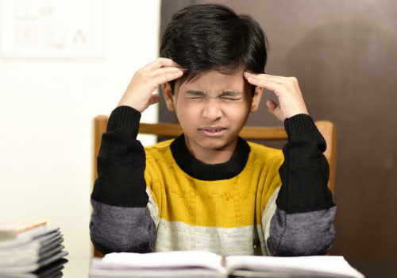
The coronavirus pandemic is bringing with it new challenges and risks for humanity. But what has been brought to light in this recent news article is not something completely unique to the pandemic situation. A meritorious 14-year-old adolescent studying in class 10 died by suicide allegedly because she didn�t have access to online classes.

There Is A Widespread Accessibility Gap That Needs To Be Acknowledged
Her father, a daily wage, had no work for about 2 months and couldn�t repair the TV set for her to access online sessions. Reportedly, she was upset with this situation of no access and also worried about whether she would be able to continue her education due to financial difficulties in the family.

Representation image. What also needs to be considered is the double disadvantage that girls might have to face especially post this pandemic, when families with limited resources might not send them to school again.
This brings us to rethink the widespread inequality, marginalization, and lack of access to opportunities in the country. A well-known fact is that suicide is the second leading cause of death in young people aged 15-29 years (WHO, 2019). The girl belonged to a marginalized community, like most students who live in poverty.

States Should Make Active Efforts To Make Online Classes Accessible For Everyone
The incident brings to the forefront how poverty permeates all aspects of one�s life, and one significant way it impacts individuals is through educational disadvantage. It is well known that children who live in poverty are less likely to do well in school (Hirsch, 2007).
What also needs to be considered is the double disadvantage that girls might have to face especially post this pandemic, when families with limited resources might not send them to school again. This will undoubtedly widen the already existing gender gap in education. We must also consider our readiness for virtual classrooms.
It has been reported that in Kerala alone, there are lakhs of students who do not have access to the necessary equipment for receiving online sessions. The state must look into and arrange for accessibility for all students, which also makes it evident how serious the education system is for the well-being of its students.

Image is for representation purposes only.
(BLOG 3) Mental Health of Children Matters: Mental Health Difficulties Faced By Children (Editors Choice)
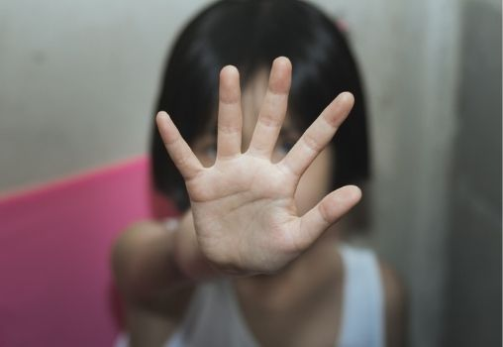
A large and growing number of children and adolescents worldwide and specifically in India, face various mental health difficulties. The Association for Children�s Mental Health (ACMH) has reported that 1 in 5 children and youth have some diagnosable emotional, behavioural, or mental health disorder.
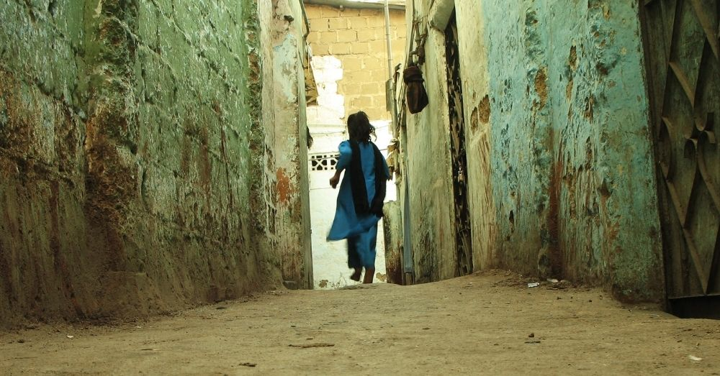
At any given point in time, nearly 50 million Indian children suffer from mental disorders, which will increase if the adolescent population is considered (Shastri, 2009). The National Mental Health Survey of India (2015-2016) had estimated that nearly 7.3% of Indian adolescents (13-17 years) suffer from mental health problems.
One of the biggest challenges in identifying mental health issues in children is usually the fact that childhood is a time of constant behavioural changes and developments. Even under the best of circumstances, one may not be able to differentiate between these changes typical to child development and those that can cause concern.
In addition, depending on their age, many children fail to express the reason behind their behaviour and actions. Also, in many cases, parents may refrain from noticing these changes or seeking support for their children due to lack of knowledge or in a bid to avoid social stigma and isolation.
But it is important to understand that many mental health disorders can occur during childhood. Many adults who seek treatment reflect on how these disorders affected their childhood and wished that they had received help sooner.
Mental health disorders in children are generally defined as delays or disruptions in developing age-appropriate thinking, behaviours, social skills or regulation of emotions. These problems are distressing to children and disrupt their ability to function well at home, in school or in other social situations. In several cases, these patterns of thinking, behaving and feeling might not lead to a diagnosable mental health condition but may still cause a negative impact on the overall functioning and well-being of the children.
The prevalence of mental health problems has only increased during the Covid-19 pandemic, which holds true for children. By spending more time at home, children are facing various emotional, behavioural and mental challenges. Parents play a pivotal role as they need to pay attention to the behaviour, habits and other mental health indicators to identify whether the child needs support. The first and most important thing is to understand the various common mental health difficulties faced by children:
- Anxiety: Anxiety problems among children usually manifest in the form of fears and worries that reduce their ability to play, participate in school activities or have usual interactions with other children. They might be suffering from social anxiety, OCDs or general anxiety.
- Attention-deficit/hyperactivity disorder (ADHD): Compared with most children of the same age, children with ADHD have difficulty with attention, impulsive behaviours, hyperactivity or some combination of these problems.
Autism spectrum disorder (ASD): Autism spectrum disorder is a neurological condition that appears in early childhood� usually before age 3. Although the severity of ASD varies, a child with this disorder has difficulty communicating, social interaction, and displaying repetitive behaviours.
- Eating disorders: Children may become obsessed with a particular body type, losing weight or binge-eating. They may obsess about eating or not consuming a specific type of food item, and such behaviours can lead to physical deficiencies, inability to perform certain tasks and even social inactivity.
- Depression and other mood disorders: Depression is when the child starts to feel sad and disinterested in activities consistently. This leads to them becoming withdrawn and less interactive at school. Extreme mood swings and emotional distress can also lead to bipolar disorder.
- Post-Traumatic-Stress-Disorder (PTSD): Long-term emotional discomfort, anxiety, nightmares and unpleasant memories caused by physical abuse, illness, injury, bereavement or any form of bullying and violence can lead to long-term emotional distress.
Mental health in children is crucial and can be prevented or treated with the right kind of professional help; guidance, support and encouragement from parents, teachers and peers. Healthy and unconditional motivation and support can enable children to develop self-belief in a responsible and sustainable manner. It is also important to include and work with the child�s school to seek the necessary support.

References:

Children and mental health. (n.d.). Retrieved February 16, 2021, from https://www.nimh.nih.gov/health/publications/children-and-mental-health/index.shtml

Here�s why parents need to address mental health issues in children. (2020, December 16).

Retrieved February 16, 2021, from https://indianexpress.com/article/parenting/health-fitness/heres-why-parents-need-to-address-mental-health-issues-in-children-7107570/

Worried about your child�s mental health? (2020, February 26). Retrieved February 16, 2021,

from https://www.mayoclinic.org/healthy-lifestyle/childrens-health/in-depth/mental- illness-in-children/art-20046577

